Busflix.in



**Busflix**

Announcement Chart

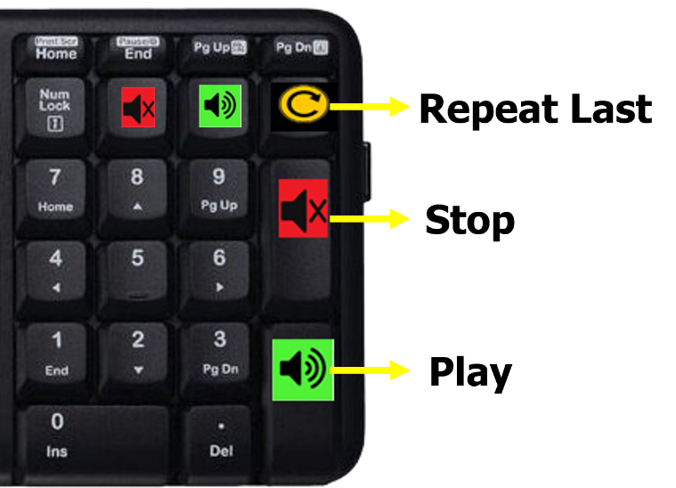



**How to use:**

**Play:** Press the correct announcement number/code and immediately press Green key on the keypad.

**Stop:** To Stop the playing announcement press Red key.

**Repeat:** To repeat the last played announcement press the yellow button.

|  |  |  |  |
| --- | --- | --- | --- |
| General | | Washroom Break | |
| **1** | Welcome | **26** | 20 min later |
| **2** | About our travels | **27** | 15 min later |
| **3** | Cleanliness rules | **28** | 10 min later |
| **4** | Busflix Entertainment | **29** | 5 min later |
| **5** | Take care of belonging | **30** | Washroom break now |
| **6** | NO dinner stop |  |  |
| **7** | Good Morning |  |  |
| Dinner | | Breakfast Break | |
| **11** | Dinner at 7 PM | **31** | 30 min later |
| **12** | Dinner at 7.30 PM | **32** | 15 min later |
| **13** | Dinner at 8 PM | **33** | 10 min later |
| **14** | Dinner at 8.30 PM | **34** | 5 min later |
| **15** | Dinner at 9 PM | **35** | Breakfast stop now |
| **16** | Dinner at 9.30 PM |  |  |
| **17** | Dinner at 10 PM |  |  |
| **18** | Dinner at 10.30 PM |  |  |
| **19** | Dinner at 11 PM |  | Your text here |
| **20** | Dinner at 11.30 PM |  |  |
| **21** | Dinner at 12 AM |  |  |
| **22** | Dinner at 12.30 AM |  |  |
| **23** | Dinner at 1 AM |  |  |
| **24** | Dinner stop NOW |  |  |

|  |  |  |  |
| --- | --- | --- | --- |
| **Code** | **AHMEDABAD TO VAPI** | **Code** | **VAPI TO AHMEDABAD** |
| **100** | Welcome to Vapi | **111** | CTM |
| **101** | Zadeshwar chokdi bharuch | **112** | Bapunagar |
| **102** | Valia chowkdi | **113** | Bus stand (geeta mandir) |
| **103** | Sarthana jakat naka | **114** | Paldi |
| **104** | Varachha | **115** | Sattalite |
| **105** | Railway station |  |  |
| **106** | Hirabaug |  |  |
| **107** | Junathana |  |  |
| **108** | Bypass chikhali (bilimora) |  |  |
| **109** | Dharampur chowkdi |  |  |
| **110** | Gunjan char rasta |  |  |
|  |  |  |  |
|  |  |  |  |
|  |  |  |  |
|  |  |  |  |
|  |  |  |  |
|  |  |  |  |
|  |  |  |  |
|  |  |  |  |
|  |  |  |  |
|  |  |  |  |
|  |  |  |  |

|  |  |  |  |
| --- | --- | --- | --- |
| **Code** | **Dropping point** | **Code** | **Dropping point** |
| **121** | Amitnagar circle | **138** | Bypass vashi |
| **122** | Krishna velly complex | **139** | Bus stand panvel |
| **123** | Golden chowkdi | **140** | Lonavala |
| **124** | Vaghodiya chowkdi | **141** | Bypass (khandala) |
| **125** | Jambua chowkdi | **142** | Nigdi |
| **126** | Gajanad complex | **143** | Pimpri - chinchavad |
| **127** | Valia chowkdi surya complex | **144** | Nashik phata |
| **128** | Kim chowkdi | **145** | Shivajinagar |
| **129** | Kamrej | **146** | Wakdevadi |
| **130** | Bypass(surat) | **147** | Pune station |
| **131** | Kadodra | **148** | Fatimanagar |
| **132** | Junatahana | **149** | Swargate |
| **133** | Dharampur chowkdi | **150** | Padmavati parking |
| **134** | Bypass vapi |  |  |
| **135** | Ghodbandar |  |  |
| **136** | Thane |  |  |
| **137** | Bus stand vashi |  |  |

**AHMEDABAD TO PUNE**

|  |  |  |  |
| --- | --- | --- | --- |
| **Code** | **Dropping point** | **Code** | **Dropping point** |
| **151** | Bus stand panvel | **161** | Kamrej chokdi |
| **152** | Bypass (vashi) | **162** | Bypass surat |
| **153** | Teen hath naka thane | **163** | Kadodra |
| **154** | Panvel | **164** | Valia chokdi surya complex |
| **155** | Vashi | **165** | Gajanad complex zadeshwar chokdi |
| **156** | Thane | **166** | Golden chokdi |
| **157** | Bypass vapi | **167** | Anand express highway |
| **158** | Dharampur char rasta | **168** | Nadiad express highway |
| **159** | Bypass chikhali seffron hotel | **169** | Vishala hotel |
| **160** | Shrinath travels junathana | **170** | Hathijan circle |
|  |  |  |  |
|  |  |  |  |
|  |  |  |  |
|  |  |  |  |
|  |  |  |  |
|  |  |  |  |
|  |  |  |  |
|  |  |  |  |
|  |  |  |  |
|  |  |  |  |
|  |  |  |  |
|  |  |  |  |

**PUNE TO AHMEDABAD**

**AHMEDABAD TO UJJAIN**

|  |  |  |  |
| --- | --- | --- | --- |
| **Code** | **Dropping point** | **Code** | **Dropping point** |
| **171** | Bus stand (Dahod road) | **179** | Rajendra nagar |
| **172** | Dahod bypass | **180** | Teen imli square |
| **173** | Bypass Jhabua | **181** | Choithram mandi square |
| **174** | Bus stand Rajgarh | **182** | Pipaliyana square |
| **175** | Mangod | **183** | Geeta bhavan road |
| **176** | Dhar bypass | **184** | Raj mohalla |
| **177** | Lebad bus stand | **185** | Aurobindo hospital gate |
| **178** | Shiv shakti hotel Ghat Bilod | **186** | Ujjain |
|  |  |  |  |
|  |  |  |  |
|  |  |  |  |
|  |  |  |  |
|  |  |  |  |
|  |  |  |  |
|  |  |  |  |
|  |  |  |  |
|  |  |  |  |
|  |  |  |  |
|  |  |  |  |
|  |  |  |  |
|  |  |  |  |
|  |  |  |  |

**UJJAIN TO AHMEDABAD**

|  |  |  |  |
| --- | --- | --- | --- |
| **Code** | **Dropping point** | **Code** | **Dropping point** |
| **191** | BYPASS DAHOD | **195** | BAPUNAGAR |
| **192** | GODHRA BYPASS | **196** | BUS STAND (GEETA MADIR) |
| **193** | RINGROAD | **197** | PALDI |
| **194** | ODHAV | **198** | SATTALITE |
|  |  |  |  |
|  |  |  |  |
|  |  |  |  |
|  |  |  |  |
|  |  |  |  |
|  |  |  |  |
|  |  |  |  |
|  |  |  |  |
|  |  |  |  |
|  |  |  |  |
|  |  |  |  |
|  |  |  |  |
|  |  |  |  |
|  |  |  |  |
|  |  |  |  |
|  |  |  |  |
|  |  |  |  |
|  |  |  |  |

**AHMEDABAD TO AURANGABAD**

|  |  |  |  |
| --- | --- | --- | --- |
| **Code** | **Dropping point** | **Code** | **Dropping point** |
| **201** | Gajanad complex Bharuch | **207** | Chalisgaon bypass |
| **202** | Valia chowkdi surya complex | **208** | Kannad bus stand |
| **203** | Bhavani mandir Kamrej | **209** | Baba petrol pump |
| **204** | Bhagvati complex Kadodra | **210** | Adalat road opp.satish motors |
| **205** | Bypass Bardoli | **211** | Shshnoormiys dargha |
| **206** | Dhule | **212** | Oasis chowk Pandharpur |
|  |  |  |  |
|  |  |  |  |
|  |  |  |  |
|  |  |  |  |
|  |  |  |  |
|  |  |  |  |
|  |  |  |  |
|  |  |  |  |
|  |  |  |  |
|  |  |  |  |
|  |  |  |  |
|  |  |  |  |
|  |  |  |  |
|  |  |  |  |
|  |  |  |  |
|  |  |  |  |

**AURANGABAD TO AHMEDABAD**

|  |  |  |  |
| --- | --- | --- | --- |
| **Code** | **Dropping point** | **Code** | **Dropping point** |
| **213** | Kamrej surat | **219** | Nadiad express highway |
| **214** | Valia chowkdi | **220** | CTM (express highway) |
| **215** | Zadeshwar chowkdi | **221** | Bus stand (Geeta mandir) |
| **216** | Sushen circle | **222** | Paldi |
| **217** | Amitnagar circle | **223** | Satellite |
| **218** | Anand express highway | **224** | Vishala hotel |
|  |  |  |  |
|  |  |  |  |
|  |  |  |  |
|  |  |  |  |
|  |  |  |  |
|  |  |  |  |
|  |  |  |  |
|  |  |  |  |
|  |  |  |  |
|  |  |  |  |
|  |  |  |  |
|  |  |  |  |
|  |  |  |  |
|  |  |  |  |
|  |  |  |  |
|  |  |  |  |

**AHMEDABAD TO SURAT**

|  |  |  |  |
| --- | --- | --- | --- |
| **Code** | **Dropping point** | **Code** | **Dropping point** |
| **231** | Zadeshwar chowkdi Bharuch | **234** | Varachha |
| **232** | Valia chowkdi Ankleshwar | **235** | Railway station Surat |
| **233** | Sarthana jakat naka |  |  |
|  |  |  |  |
|  |  |  |  |
|  |  |  |  |
|  |  |  |  |
|  |  |  |  |
|  |  |  |  |
|  |  |  |  |
|  |  |  |  |
|  |  |  |  |
|  |  |  |  |
|  |  |  |  |
|  |  |  |  |
|  |  |  |  |
|  |  |  |  |
|  |  |  |  |
|  |  |  |  |
|  |  |  |  |
|  |  |  |  |
|  |  |  |  |

**SURAT TO AHMEDABAD**

|  |  |  |  |
| --- | --- | --- | --- |
| **Code** | **Dropping point** | **Code** | **Dropping point** |
| **241** | CTM | **246** | Ramol |
| **242** | Bapu nagar | **247** | Ring road |
| **243** | Bus stand (Geeta mandir) | **248** | Uttamnagar |
| **244** | Paldi | **249** | Jivanwadi |
| **245** | Satellite |  |  |
|  |  |  |  |
|  |  |  |  |
|  |  |  |  |
|  |  |  |  |
|  |  |  |  |
|  |  |  |  |
|  |  |  |  |
|  |  |  |  |
|  |  |  |  |
|  |  |  |  |
|  |  |  |  |
|  |  |  |  |
|  |  |  |  |
|  |  |  |  |
|  |  |  |  |
|  |  |  |  |
|  |  |  |  |